Smart Water Uses Monitoring system in Aquarium

Samikshya Dhamala

BSc. (Hons) in Computer Science with Artificial Intelligence, Sunway College Kathmandu

Brimingham City University, UK

Kathmandu – 14, Nepal

[samikshya.dhamala@mail.bcu.ac.uk](mailto:samikshya.dhamala@mail.bcu.ac.uk)

*Abstract* — Water quality is a crucial parameter in maintaining a healthy aquatic ecosystem, particularly in aquariums where fish and other aquatic creatures rely on a stable environment. The traditional method of checking water parameters is manual, time-consuming, and prone to human error. This research proposes an IoT-based Smart Water Usage Monitoring System for Aquariums to automate water quality management. This study demonstrates how IoT-driven smart monitoring can revolutionize water quality management in aquariums, providing a scalable and efficient solution that contributes to sustainability and improved aquatic health. The device integrates a number of sensors, including pH, dissolved oxygen (DO), turbidity, temperature, and ultrasonic sensors, to track significant water parameters in real-time. Real-time information is analyzed by an Arduino microcontroller and triggers automatic reactions via LED lights, a buzzer, and a servo motor to realize proactive control of water quality. Moreover, security features such as encryption of data, access control, and firmware upgrade are considered to ensure the system's integrity and reliability. Not only does this IoT-based approach optimize the sustainability of aquarium ecosystems, but also reduces human intervention, so it is a viable and innovative technique for fishkeeping hobbyists and aquaculture industries.

Keywords: *modern computing, iot, aquarium, arduino, pH, DO(dissolved oxygen), turbidity, microcontroller, encryption, water monitor*

# INTRODUCTION

In modern society, many people keep pets to accompany them. However, as compared to big pets such as cats and dogs, which need one to spend time outdoors, pet fish only need to be fed on a daily basis and have their water changed occasionally. Pet fish can also be employed in the decoration of a home as well as be psychologically comforting; looking at them can help one relax, and for this reason many people today keep them (Sung, Tasi and Hsiao, 2022). In a survey in the United States in 2020, it was found that of all pets, the proportion of people keeping pet fish was the largest (American Veterinary Medical Association, 2024). So, We can use the Internet of Things' (IoT) power to leverage the newest sensor technologies and create automated systems that guarantee the monitoring and management of these crucial parameters at all times, ultimately improving the aquatic health.

In particular, it is necessary to make them feel comfortable and secure and continuously maintain it. An unfavorable environment In particular, they should be kept safe and secure and consistently do so. An unfavorable environment may affect the growth of fish and even kill them (Mugwanya et al., 2022). The role of this system is to sense the temperature, Dissolved oxygen (DO), water level and turbidity of an aquarium and to also detect the pH value of the water. The system has certain threshold aquarium environment limits, and it compares the incoming signals from the sensors with control and optimizes the outputs. This research paper is aligned with SDG Goal 6: Clean Water and Sanitation and SDG Goal 12: Responsible Consumption and Production.

# LITERATURE REVIEW

## **A.Internet of Things (IoT) as an Enabler of Digitizing the Physical World**

In the world of modern computing, nearly every sector, from retail to health care, has some form of investment in IoT. The International Data Cooperation has predicted that data will increase to 163 zettabytes by 2025 and volume of data will be high to 163 zettabytes in 2016 (Santos & Ferreira, 2019). In Switzerland, Decentlab sensors were integrated to enable precision water level measurements and proactive anomaly detection. The IoT network triggers automatic alerts when water levels drop, preventing potential pump damage (IoT Environmental Monitoring - Everything you need to know, n.d.). Similarly, the scope iot is in every field because of its conveniency.

## **B.The present and forthcoming advances in the computing technology**

In recent times massive amount of connectivity, security, great consistency, and very low latency is waiting for IoT implementation with fresh new business where IoT is delivering greater data rates, improved coverage to enable robots' actuators and drones with 5G booms (Shafique et al., 2020). Computing paradigms with emerging standards like cloud, fog, edge, serverless and quantum computing environments have various research opportunities for leveraging AI and ML which is very important to identify (Gill et al., 2022) and new standards have emerge as well as new terms like “Smart home”, Smart cities” and “Smart industry” which all work for data utilization and automated decision making which can be execute by using AI and ML techniques.

The integration of blockchain and IoT can generate various smart assets, connecting the gap between the physical world and virtual cyberspaces with the help of virtual and real interaction through parallel development which helps to identify optimal management scheme (Wang et al., 2019). Cloud computing can add valuable amplification to an intelligent power system which is designed to solve significant data from various areas within a smart power grid. The challenges and their implication help in contribution of literature review evaluation (AL-Jumaili et al., 2023).

## **C. Modern Networking and System Security Approaches**

With the application of machine learning the blending of various internet of thing (IoT) which are affiliated within the modern power system is leading to various security and stability crisis which is because of some protocol and standards are exposed to cyberattacks and intrusion (Alimi et al., 2020). (Alzoubi et al., 2022) analyses blockchain as a viable platform for addressing Fog Computing (FC) obstacles including three primary security goals (i.e. Confidentiality, integrity, availability) in which blockchain based solution is identified as modular and robust to various security and privacy threats.

## **D.Water Quality Parameters for Aquatic Life**

Fish living in aquarium needs constant monitoring and required a lot of care. A lot of factors are needed to be considered to keep the fish healthy. In general, most freshwater fish prefer a temperature range of 72-82°F (22-28°C) (www.aqueon.com, n.d.). Maintaining the correct temperature is important for several reasons. Most freshwater fish are happy at pH levels between 6.5 to 8.0 pH in a fish tank naturally changes throughout the day (O’Donnell, 2023). The turbidity needs to be below 600 for the fish to swim properly (Lethal Turbidity Levels for Common Fish and Invertebrates in Auckland Streams, 2002). Fish require dissolved oxygen levels between 5-6 ppm (parts per million) to grow and thrive (Atlas Scientific, 2022).

# METHODOLOGY

The objective of this study is to develop an IoT-based Smart Water Usage Monitoring System for aquariums to automate water quality management. This system aims to :

* Minimize human interaction and prevent errors in manual water analysis.
* Incorporate LED indicators, buzzer alerts, and a system of servo motors in order to introduce automated corrective actions when parameters exceed unsafe conditions.
* Provide stable water conditions to support healthy growth and well-being of fish.
* Align with sustainability goals (SDG 6 & SDG 12) by optimizing water use and reducing waste in aquarium systems.
* Create a cost-effective, user-friendly, and adaptable solution that can be extended to smart cities and environmental monitoring.

## **A.Brief About Proposed System and Its Working**

The Backbone of modern water management is smart infrastructures. Smart water uses monitoring systems using Internet of Things (IOT) offer a low-cost solution for real-tine monitoring of water quality. In particular, smart water uses monitoring system in an aquarium is an efficient and cost-effective solution which mainly helps to create a best environment for fish to survive. These systems employ different types of sensors, such as temperature sensors, pH sensors, turbidity sensors, ultrasonic sensors, and water, and dissolved oxygen sensor to detect changes in environmental phenomena of fish in the aquarium. The project automates fish care by maintaining pH, water level, turbidity, temperature and dissolved oxygen that saves time, reduces effort, and ensures an optimal aquarium environment. This system also alerts clients, providing them with real-time monitoring and control.

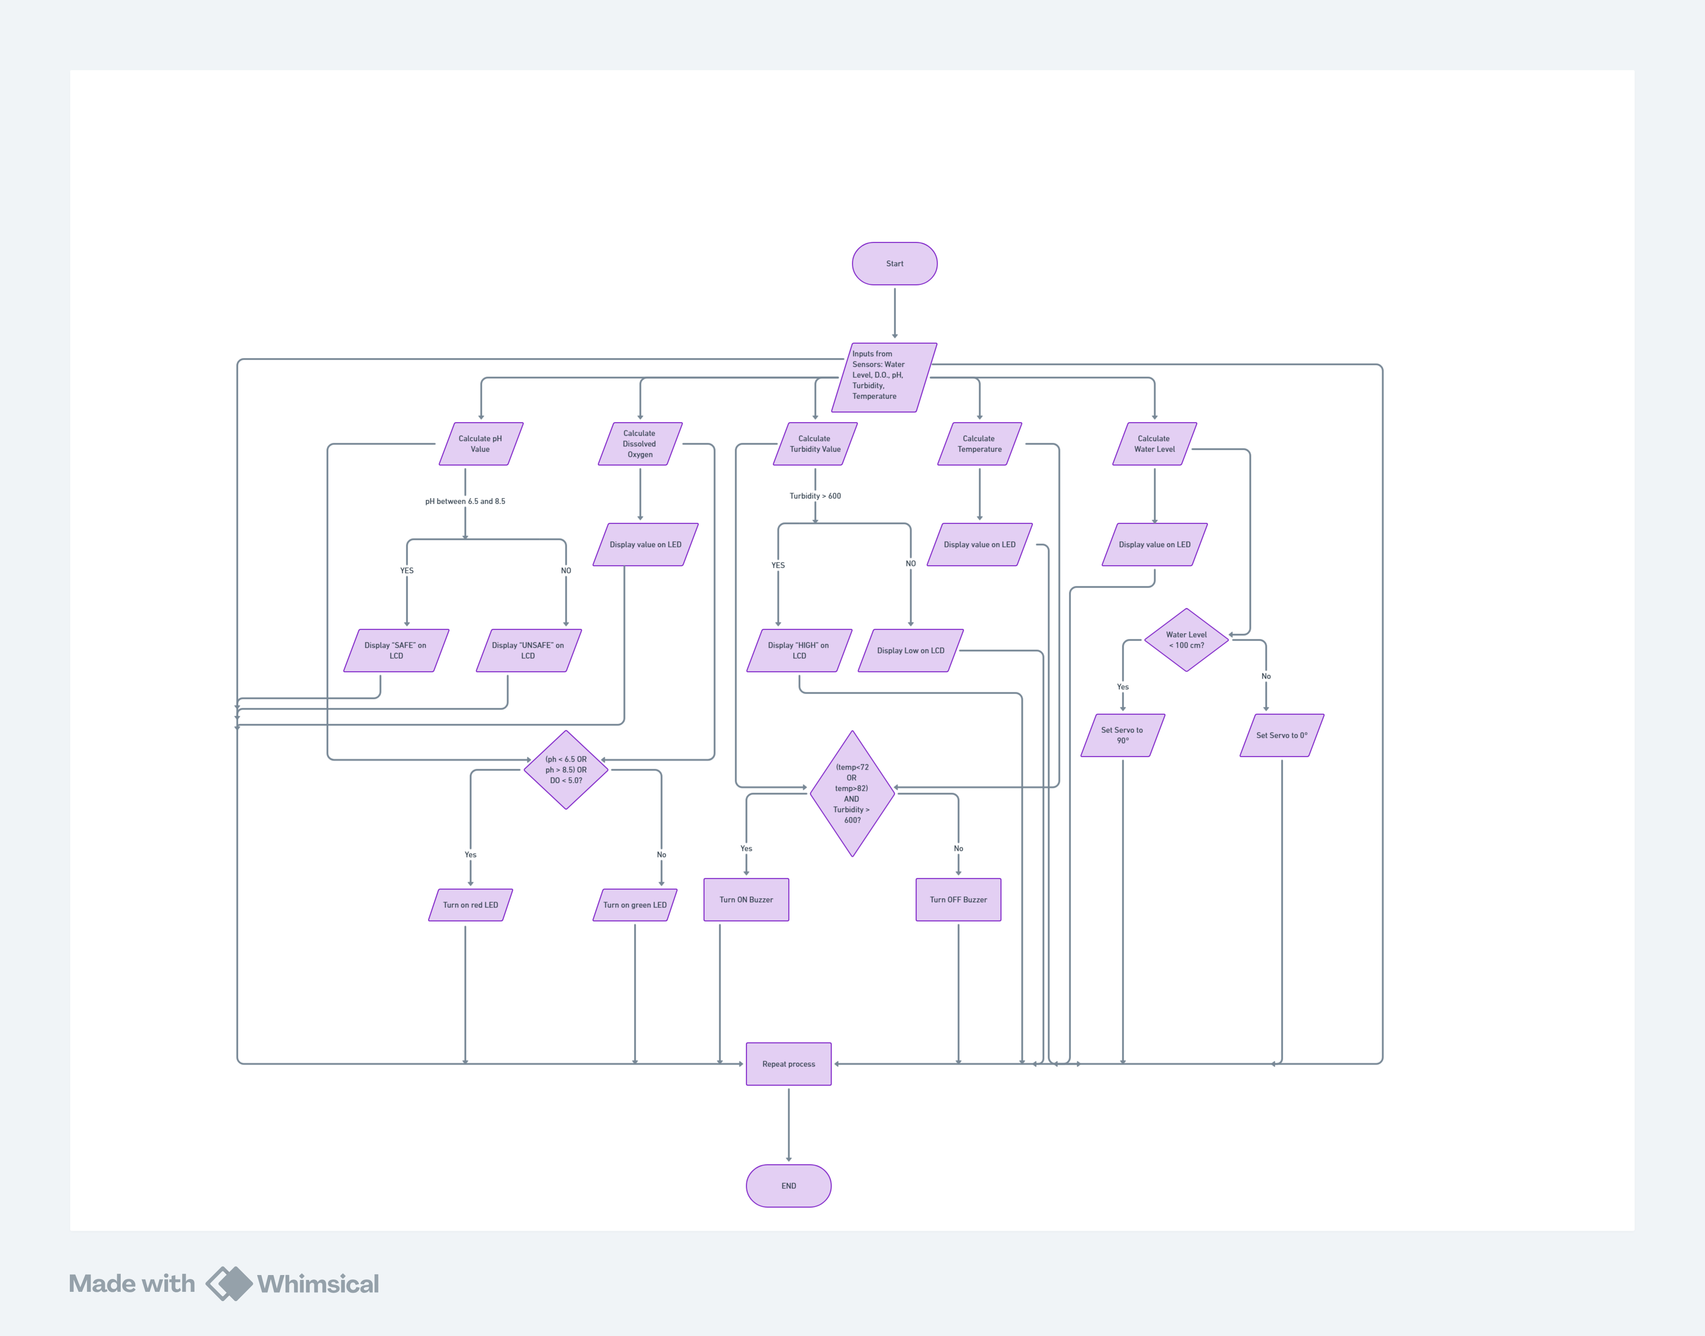

*Fig 1. Flow chart of the system.*

Our framework utilizes an Arduino UNO microcontroller as the center hub for data processing. An ultrasonic sensor is used to keep track of the water level in the aquarium, activating the micro servo to open when the water level is low which is less than 100 cm. Since the dissolved oxygen (DO) and pH sensors are unavailable in Tinkercad, I simulate these sensors using a potentiometer. The dissolved oxygen (DO) sensor tracks oxygen levels, showing the value in the screen whereas the pH sensors monitor the water’s acidity or alkalinity, by displaying “SAFE” on the screen if its value is in between 6.5 and 8.5 otherwise display “UNSAFE”, preventing harmful chemical imbalances. The temperature sensors ensures that the water remains within the optimal range for aquatic life and the data is shown on the LCD. Additionally, an LDR sensor simulates the turbidity sensor, evaluating water clarity and detecting excessive particles that may indicate contamination and display” HIGH” if it exceeds the turbidity threshold which is 600 NTU otherwise display “low”. Along with this some special features are used to make the system more systematic like the buzzer activates at 100 intensity level if the temperature is either below the low threshold which is 72 °F or above the high threshold which is 82 °F, and if the turbidity value is greater than the turbidity threshold. Similarly, if the pH value is outside the safe range or if the oxygen value is below the DO threshold (5 ppm), the red warning LED turns on (indicating unsafe pH or DO levels), and the green LED turns off.

## **B.Truth Table**

The given truth table describes how logic is used in smart water uses monitoring system where two output term “Off” and “On” are used and “1” is used for safe and “0” is used for unsafe. The truth table provides the final output based on the logic applied in the system. For e.g. the output alert unsafe “0” when all the inputs are unsafe and high or any of the input is unsafe. In the same way, if pH sensor, DO sensors, turbidity sensor and temperature sensors are safe and low then the system alert safe.

Table 1. Truth table of the system.

|  |  |  |  |  |  |
| --- | --- | --- | --- | --- | --- |
| Cases | pH (Safe=1, Unsafe=0) | DO (Safe=1, Unsafe=0) | Turbidity (High=1, Low=0) | Temp (Safe=1, Unsafe=0) | Alert (Safe=1, Unsafe=0) |
|  | *A* | *B* | *C* | *D* | *Q* |
| 1 | 0 | 0 | 0 | 1 | 0 |
| 2 | 0 | 0 | 0 | 0 | 0 |
| 3 | 0 | 0 | 1 | 1 | 0 |
| 4 | 0 | 0 | 1 | 0 | 0 |
| 5 | 0 | 1 | 0 | 1 | 0 |
| 6 | 0 | 1 | 0 | 0 | 0 |
| 7 | 0 | 1 | 1 | 1 | 0 |
| 8 | 0 | 1 | 1 | 0 | 0 |
| 9 | 1 | 0 | 0 | 1 | 0 |
| 10 | 1 | 0 | 0 | 0 | 0 |
| 11 | 1 | 0 | 1 | 1 | 0 |
| 12 | 1 | 0 | 1 | 0 | 0 |
| 13 | 1 | 1 | 0 | 1 | 1 |
| 14 | 1 | 1 | 0 | 0 | 0 |
| 15 | 1 | 1 | 1 | 1 | 0 |
| 16 | 1 | 1 | 1 | 0 | 0 |

The above truth table gives the following:

Boolean expression,

*Simplified form:*

*= .D* (De Morgan’s Theorem)

*or, Q= (A.B). ( .D)*

*or, Q= ABD*

## **C.Logic diagram**

Two levels of logic ("0" and "1") are possible for both the input and output states of any binary logic gate. AND, OR, and NOT gates are exemplary instances of binary gates. While the NOT gate only requires one input to create one output, the AND and OR gates require two or more inputs to produce one output. The AND binary gate's rule states that the output is 1, if every input is 1 and 0 otherwise. When one of the inputs is 1, the OR gate produces an output of 1. The output state of the NOT gate, also known as an inverter gate, is the opposite of the input state.

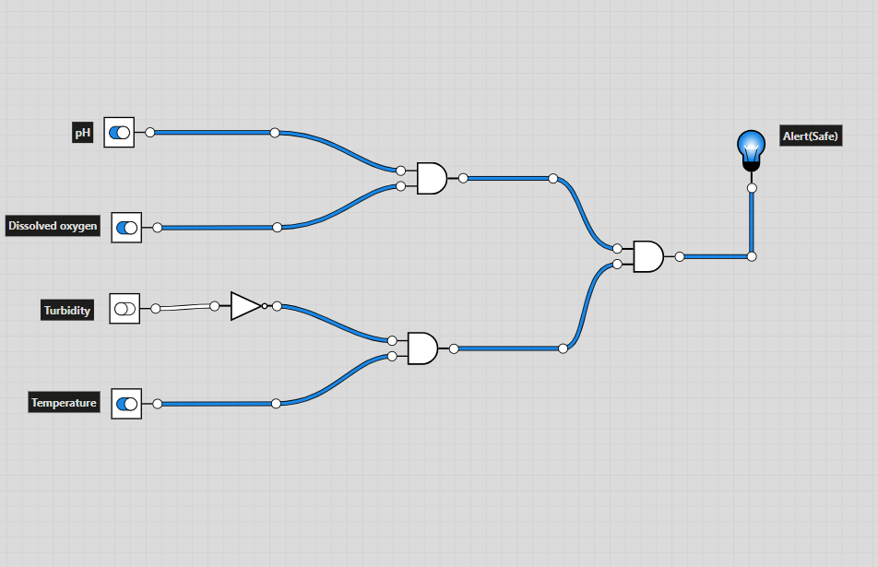From the above Boolean expression, a logic circuit can be created to better demonstrate how the system functions,

*Fig 2. Logic diagram of the system using Logicly.*

## **D.Hardware and Require Components**

1. *Arduino*

Arduino features an 16 MHz clock speed , six analog inputs, 14 digital input and output pins, a USB port, a power jack, an ICSP header, and a reset button (Chaudry, 2020).It is programmable with the free Arduino IDE using C and C++ programming language (Wikipedia Contributors, 2019). Since, it is easy to program, has multiple pins, supports I2C communication and make troubleshooting easy I prefer to use Arduino in my project.

1. *Ultrasonic sensors*

Ultrasonic sensors are devices that use high-frequency sound waves to detect the presence of objects or measure distances (Robocraze, 2022). They work by emitting sound waves that bounce off objects and return to the sensor, which then calculates the distance based on the time it takes for the echo to return. It can measure distance up to 4.5 meters away(Singh & Kapoor, 2021).To measure the water level of the tank by calculating the time sound waves take to return after hitting the water surface, I use ultrasonic sensor.

1. *Photoresistor as Turbidity sensor*

A photoresistor can be used as a light detector in a turbidity sensor for IoT applications (Keat and Kok, 2022). Turbidity sensors measure the amount of light scattered by suspended particles in a liquid, which indicates the liquid's clarity or cloudiness.To measure the turbidity level of water in the tank, I use turbidity sensor.

1. *Potentiometer*

The basic principle of the potentiometer is that the potential drop across any section of the wire will be directly proportional to length of the wire, given a uniform cross-sectional area and constant current. A potentiometer can function as a sensor in IoT applications by measuring position, displacement, or angle and converting it into an electrical signal (Byjus.com, 2022).

1. *Potentiometer as a Dissolved Oxygen sensor*

* Because potentiometric sensors can detect oxygen concentration immediately and accurately, they are frequently utilized for dissolved oxygen (DO) monitoring in Internet of Things applications (Zimmermann et al., 2018). The potential difference at an electrode surface, which changes depending on the amount of oxygen in the solution, is measured by these sensors (R. Martinez-Manez et al., 2005). Since DO is one of the key feature for the survival of fish, I use potentiometer for monitoring oxygen levels in water.

1. *Potentiometer as a pH sensor*

The potentiometer measures the voltage by comparing an unknown voltage to a known voltage, as the pH sensor it measure the potential difference related to the hydrogen ion concentration in a solution (Hossain et al., 2024). By adjusting the potentiometer, you can vary the input to the microcontroller, effectively emulating different pH levels. I use pH sensor since it measures acidity/alkalinity of water, which is crucial for aquatic life.

1. *Temperature sensor*

IoT temperature sensors measure heat and convert these measurements into data use for diverse applications, with models spanning from -200°C to 370°C using thermistors, thermocouples, and resistor temperature detectors (RTD) inside it (Helen, 2024). I use temperature sensor to ensures water temperature stays within safe limits for fish.

## **E.Sustainable goals**

1. *Aligning with SDG Goal 6: Clean Water and Sanitation*

This study aims to improve water quality monitoring in aquariums by utilizing IoT sensors for real-time monitoring of pH, temperature, turbidity, and dissolved oxygen levels, thereby improving sustainable use of water and facilitating the achievement of SDG Goal 6.

1. *Aligning with SDG Goal 12: Responsible Consumption and Production*

Intelligent water monitoring system is designed to make the fullest possible use of water, reducing wastage and conserving as much as possible and thus facilitating SDG Goal 12 of careful use of water resources.

## **F.Hardware Architecture using Tinker CAD**

We used different components for simulation because TinkerCad does not provide all the components we needed for our design. The dissolved oxygen sensor (attached to analog pin A2) and pH sensor (attached to analog pin A0) are simulated using a potentiometer. Attached to analog pin A1, an LDR sensor serves as a substitute for the turbidity sensor. Analog pin A3 is where the temperature sensor is connected. We utilized an ultrasonic sensor to monitor the water level, with the trigger pin attached to digital pin ~9 and the echo pin to digital pin 10. Digital pin ~6 is coupled to a micro servo motor that acts as a gate. The **LCD display** is connected to **A4 and A5**, and a **piezo buzzer** is connected to **digital pin ~5** for alerts.

The outcome of this approach is a simple smart water uses monitoring system. The led, buzzer and different sensors provide more options for automation and control, making it user friendly, practical, and flexible solution.

#### 

*Fig 3. Circuit diagram of the system (Tinkercad).*

## **G.Schematic Diagram of the Smart Water uses Monitoring System**

A schematic diagram is a designed representation of the elements of a system using abstract, graphic symbols rather than realistic pictures. With the help of Tinkercad I made this diagram.

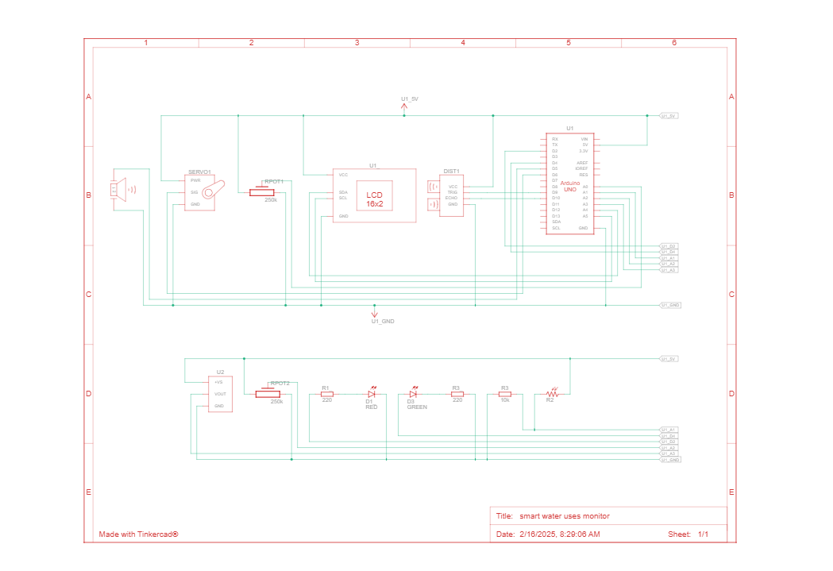

*Fig 3. Schematic diagram (Tinker cad)*

*Fig 3. Schematic diagram (Tinkercad)*

## **H.Code**

Code snippet of the system using C++. The complete code is available at GitHub- <https://github.com/samikshyadhamala/Water-Usages-Monitor-System-IOT>

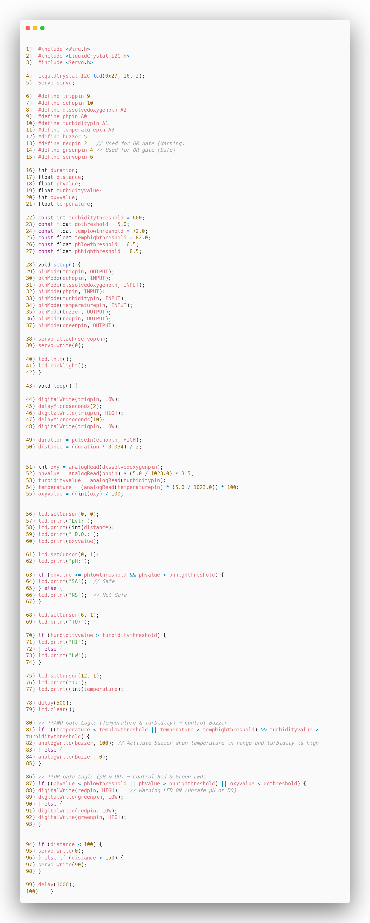





*Fig 4. Code of my system in Tinkercad*

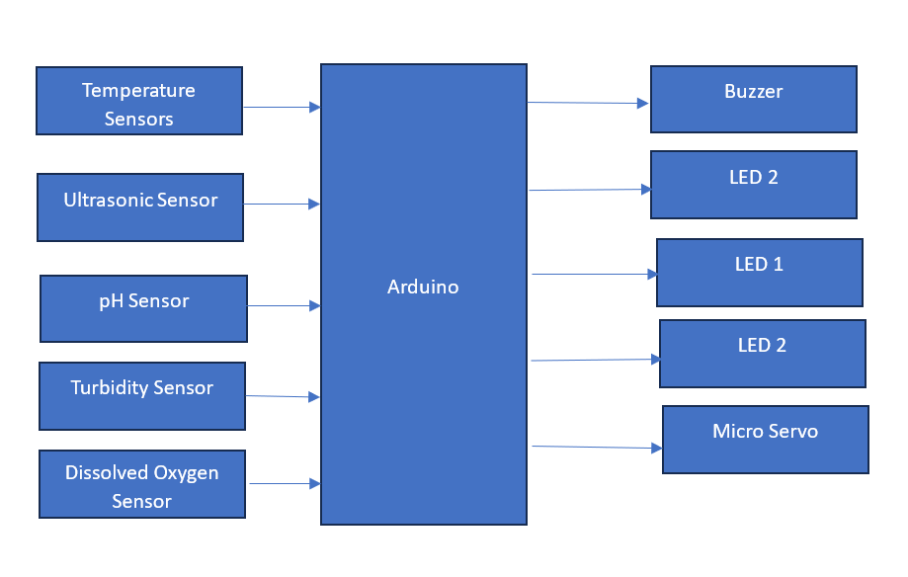

*Fig 5. Block Diagram of the system*

*Table 2. Component List of smart power monitoring system*

|  |  |  |
| --- | --- | --- |
| Name | Quantity | Components |
| U1 | 1 | Arduino Uno R3 |
| LCD1 | 1 | 16x2 LCD (I2C, PCF8574-based) |
| SERVO1 | 1 | Servo Motor (SG90 or equivalent) |
| US1 | 1 | Ultrasonic Distance Sensor (HC-SR04) |
| REPO1  REPO2 | 2 | 250 kΩ Potentiometer simulation of pH and Dissolved oxygen sensors |
| LDR1 | 1 | Photoresistor as a simulation of turbidity sensor |
| TEMP1 | 1 | Temperature Sensor (DS18B20 or equivalent) |
| PING1 | 1 | Ultrasonic Distance Sensor |
| BZ1 | 1 | Buzzer |
| LED1 | 1 | Red LED (Warning Indicator) |
| LED2 | 1 | Green LED (Safe Indicator) |
| R1 | 1 | 220Ω Resistor (for LEDs) |
| R2 | 1 | 1kΩ Resistor |
| W1 | 1 | Connecting Wires & Jumper Wires |
| S1 | 1 | Slide switch |
| PCB1 | 1 | Breadboard or PCB for connections |

# RESULTS

By combining several sensors and logic gates, the suggested smart water monitoring system effectively achieves its goal of ensuring the best possible conditions for aquarium water quality. The system utilizes an ultrasonic sensor for distance measurement, a pH sensor to monitor the water's acidity, a turbidity sensor to gauge water clarity, a dissolved oxygen sensor to measure oxygen levels, and a temperature sensor for environmental control. The sensor data is displayed in real-time on an LCD, offering users a clear overview of the water quality. The result of the system is that the lcd display clear if all the sensors receive the safe value required comparing it with the given threshold value of corresponding sensors. For example, red and green LEDs show safe or unsafe pH and dissolved oxygen levels, and a buzzer is triggered when temperature and turbidity above threshold values, indicating a problem. Furthermore, a servo motor can regulate automatic functions like water flow by adjusting in response to distance readings.

# DISCUSSION

1. *System Discussion*

The project maintains temperature, pH, and water level to automate fish care. offers the best possible aquarium environment while saving time and effort. It tracks attributes like water flow and quality regularly, allowing for early maintenance and decision-making. Fixing issues like sensor accuracy is necessary, and user involvement is essential to maximizing the advantages. When everything is taken into account, the system offers a practical choice for efficient and long term water management.

1. *Security Consideration*

Security is essential for system implementation because it ensures system integrity and safeguards sensitive data. When developing smart water uses monitoring systems using IoT devices, it's critical to evaluate security risks and establish practical mitigation strategies to safeguard users' safety and privacy. For an IoT device, security is crucial. Numerous IoT devices include flaws that could lead to potential dangers and issues. Therefore, it is essential to include security measures in IoT devices, such as communication encryption, firewall settings, access control, and strong authentication.

The power supply needs to be protected from interruptions, and the sensors, microcontroller, and wires need to be kept in tamper-proof enclosures to avoid unwanted tampering. Passwords and user rights are two effective authorization techniques that are required to control system access and prevent unauthorized access. Private information shared between sensors and the computer's CPU can be safeguarded by data encryption. Regular software updates and patches are necessary to address vulnerabilities and maintain system security. Legal requirements for data privacy must be complied with by putting in place robust data privacy protections. Prioritizing these security procedures lowers the likelihood of data breaches, unauthorized access, and system vulnerabilities, ensuring that the system operates as intended.

1. *Technological Competitiveness*

The Smart Water Usage Monitor for Aquariums provides a highly competitive technology solution in the growing market of IoT-based environmental monitoring systems. With the integration of multiple sensors (e.g., pH, turbidity, dissolved oxygen, temperature, and distance sensors) with real-time data processing and automatic control, the system provides an end-to-end solution to maintain water quality in aquariums. Being an alternative to traditional methods that require manual intervention and checks, the system utilizes both AND and OR gates to enable automated decision-making processes, raising accuracy and water management efficiency*.*

# FUTURE RECOMMENDATION

To enhance the feature of “Smart Water uses monitor System in Aquarium” some of the future recommendations are mention below:

* Integration with AI for predictive analysis
* Mobile and cloud integration
* Automatic water filtration and Refilling system
* Solar powered system for energy efficiency

# CONCLUSION

Thus, in this report, a Smart Water Usage Monitoring System for Aquariums has been created, utilizing advanced IoT technologies for enhancing water quality management and conservation. The system is built using various components, including Arduino microcontrollers, ultrasonic sensors, pH sensors, turbidity sensors, dissolved oxygen sensors, and temperature sensors. These sensors are integrated together to provide comprehensive monitoring and automated control features, offering the optimum condition for aquarium management.

The report details the design process and operation of the system, demonstrating how the integrated sensors constantly monitor real tome water quality parameters and triggers automatic responses in accordance with specified thresholds. The system modifies the environment automatically with output such LED indicators, an alarm buzzer and a servo motor for physical control, and thus it is efficient and safe for aquarium management.

But the report also emphasizes that there is a requirement for effective security features in order to protect both the system and the users from the potential threats of IoT devices. Secure authentication technologies, encrypted data communication, firmware upgrades, and network security features must be present to ensure the integrity and security of the system. Not only does the system enhances aquatic ecosystem management but also user ease and aquatic life safety. As technology evolves, adding more advanced features and enhancing the functionality of IoT are likely to make such systems even more effective and adaptable to a wider range of environments, leading to more efficient and user-friendly water monitoring and conservation solutions.

In conclusion, the system presents an organized approach to water management, employing sensors to track important variables and take appropriate action. The technology helps achieve sustainability goals by facilitating better water consumption and quality management through real-time monitoring and informed decision-making. This method, which prioritizes security considerations, presents a viable answer for a variety of applications.

##### REFERENCE

Zhang, K., Ye, Z., Qi, M., Cai, W. and Zhao, J. (2024). Water Quality Impact on Fish Behavior: A Review From an Aquaculture Perspective. *Reviews in Aquaculture*. [online] doi:https://doi.org/10.1111/raq.12985.

Chaudry, A.M. (2020) ‘Using Arduino Uno microcontroller to create interest in physics’, *The Physics Teacher*, 58(6), pp. 418–421. doi:10.1119/10.0001841.

Wikipedia Contributors (2019). *Arduino Uno*. [online] Wikipedia. Available at: https://en.wikipedia.org/wiki/Arduino_UNO.

Singh, B. and Kapoor, M. (2021) ‘A framework for the generation of obstacle data for the study of obstacle detection by ultrasonic sensors’, *IEEE Sensors Journal*, 21(7), pp. 9475–9483. doi:10.1109/jsen.2021.3055515.

Keat, T. and Kok, Y. (2022). *EVALUATION OF TURBIDITY MEASURING USING IOT BASED SENSORS*. [online] Available at: https://eprints.usm.my/55717/1/Evaluation%20Of%20Turbidity%20Measuring%20Using%20IoT%20Based%20Sensors_Tay%20Ying%20Keat.pdf [Accessed 15 Feb. 2025].

Santos and Ferreira (2019) ‘IOT Power Monitoring System for Smart Environments’, Sustainability, 11(19), p. 5355. doi:10.3390/su11195355.

American Veterinary Medical Association (2024). *U.S. pet ownership statistics*. [online] American Veterinary Medical Association. Available at: https://www.avma.org/resources-tools/reports-statistics/us-pet-ownership-statistics.

Atlas Scientific (2022). *Dissolved Oxygen In Water: PPM For Fish*. [online] Atlas Scientific. Available at: https://atlas-scientific.com/blog/dissolved-oxygen-in-water-ppm-for-fish/.

Byjus.com. (2022). *...* [online] Available at: https://byjus.com/question-answer/explain-the-principle-of-potentiometer/.

Fao.org. (2025). *FAO Knowledge Repository*. [online] Available at: https://openknowledge.fao.org/handle/20.500.14283/ [Accessed 15 Feb. 2025].

Helen (2024). *What Is IoT? Top 16 IoT Sensors And Applications - Renke*. [online] Renke. Available at: https://www.renkeer.com/iot-sensors-applications/.

Hossain, Md.S., Padmanathan, N., Badal, Md.M.R., Razeeb, K.M. and Jamal, M. (2024). Highly Sensitive Potentiometric pH Sensor Based on Polyaniline Modified Carbon Fiber Cloth for Food and Pharmaceutical Applications. *ACS Omega*. doi:https://doi.org/10.1021/acsomega.4c06090.

IoT Environmental Monitoring - Everything you need to know. (n.d.). *IoT Environmental Monitoring - Everything you need to know*. [online] Available at: https://www.loriot.io/blog/environmental-monitoring-01.html.

Keat, T. and Kok, Y. (2022). *EVALUATION OF TURBIDITY MEASURING USING IOT BASED SENSORS*. [online] Available at: https://eprints.usm.my/55717/1/Evaluation%20Of%20Turbidity%20Measuring%20Using%20IoT%20Based%20Sensors_Tay%20Ying%20Keat.pdf [Accessed 15 Feb. 2025].

Mugwanya, M., Dawood, M.A.O., Kimera, F. and Sewilam, H. (2022). Anthropogenic temperature fluctuations and their effect on aquaculture: A comprehensive review. *Aquaculture and Fisheries*, [online] 7(3), pp.223–243. doi:https://doi.org/10.1016/j.aaf.2021.12.005.

R. Martinez-Manez, Camino, J.S., E. Garcia-Breijo, Sanchez, L.G., J. lbanez Civera and Morant, E.G. (2005). Potentiometric dissolved oxygen sensors with reference electrode integrated in thick film technology. *Potentiometric Dissolved Oxygen Sensors with Reference Electrode Integrated in Thick Film Technology*, [online] (2163-4971), pp.593–595. doi:https://doi.org/10.1109/sced.2005.1504526.

robocraze (2022). *What Is Ultrasonic Sensor: Working Principle & Applications*. [online] Robocraze. Available at: https://robocraze.com/blogs/post/what-is-ultrasonic-sensor.

Sung, W.-T., Tasi, S.-C. and Hsiao, S.-J. (2022). Aquarium Monitoring System Based on Internet of Things. *Intelligent Automation & Soft Computing*, 32(3), pp.1649–1666. doi:https://doi.org/10.32604/iasc.2022.022501.

VEDANTU. (n.d.). *Potentiometer Working - Principle & Diagram*. [online] Available at: https://www.vedantu.com/physics/potentiometer-working.

Wikipedia Contributors (2019). *Arduino Uno*. [online] Wikipedia. Available at: https://en.wikipedia.org/wiki/Arduino_UNO.

Zhang, K., Ye, Z., Qi, M., Cai, W. and Zhao, J. (2024). Water Quality Impact on Fish Behavior: A Review From an Aquaculture Perspective. *Reviews in Aquaculture*. [online] doi:https://doi.org/10.1111/raq.12985.

Zimmermann, P., Weltin, A., Urban, G.A. and Kieninger, J. (2018). Active Potentiometry for Dissolved Oxygen Monitoring with Platinum Electrodes. *Sensors (Basel, Switzerland)*, [online] 18(8). doi:https://doi.org/10.3390/s18082404.

O’Donnell, D. (2023). *Aquarium Water pH Maintenance - Sensorex Liquid Analysis Technology*. [online] Sensorex Liquid Analysis Technology. Available at: <https://sensorex.com/aquarium-ph/>.

Lethal Turbidity Levels for Common Fish and Invertebrates in Auckland Streams. (2002). Available at: http://www.aucklandcity.govt.nz/council/documents/technicalpublications/ARC-TP-337.pdf.